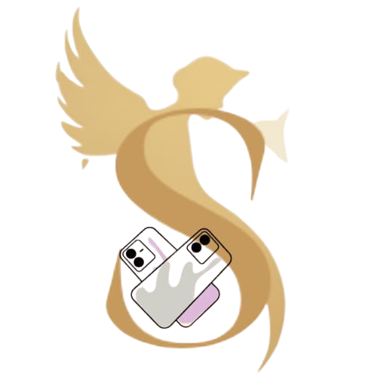 SERAPHINA COVERS
-Seraphina Jerlin D

Customizable Mobile Case :-

Product Idea:
My product is a customizable mobile phone case that allows users to express their unique style. Customers can choose from a variety of designs, colors, patterns, and even upload their own images or text to create a personalized phone case that reflects their personality. The product combines protection with creativity, making it both functional and fashionable.
Target Audience:
The primary audience includes teenagers, young adults, and tech-savvy individuals who enjoy personalization and want their accessories to stand out. This product also appeals to gift buyers looking for unique and thoughtful presents for friends and family.
Tools Used:
- Flyer: Designed using Canva, featuring eye-catching visuals and concise product information.
- Video: Created using InShot, demonstrating the customization process and product features.
- Website: Built with VS Code and enhanced with content and ideas generated using ChatGPT, providing an interactive and user-friendly platform for orders and customization.

